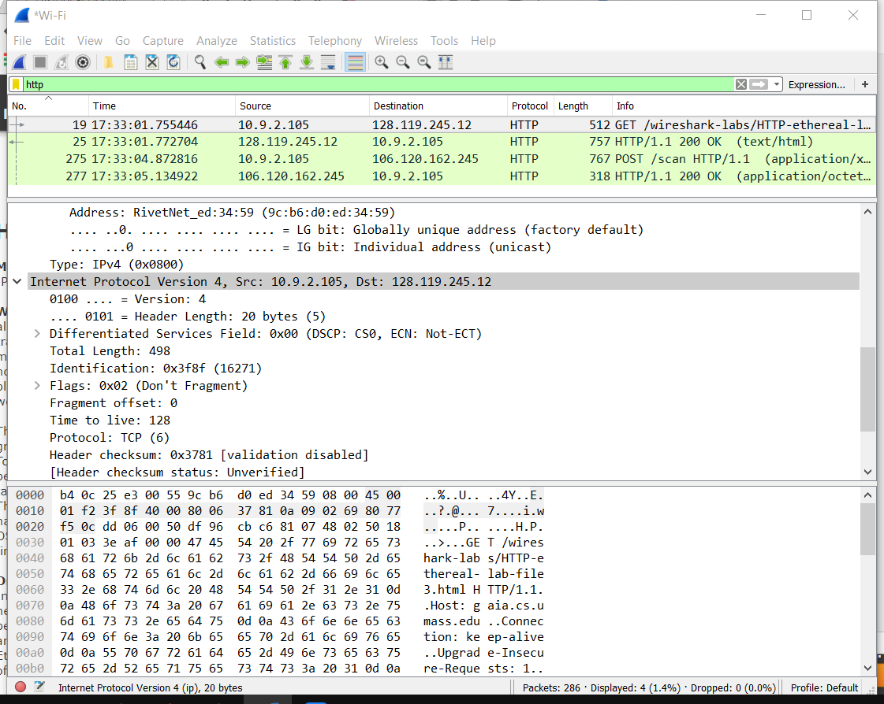Wenjie Xu **Lab6**

The screen shot of my IP address:

10.9.2.105

1. What is the MAC address from your computer?

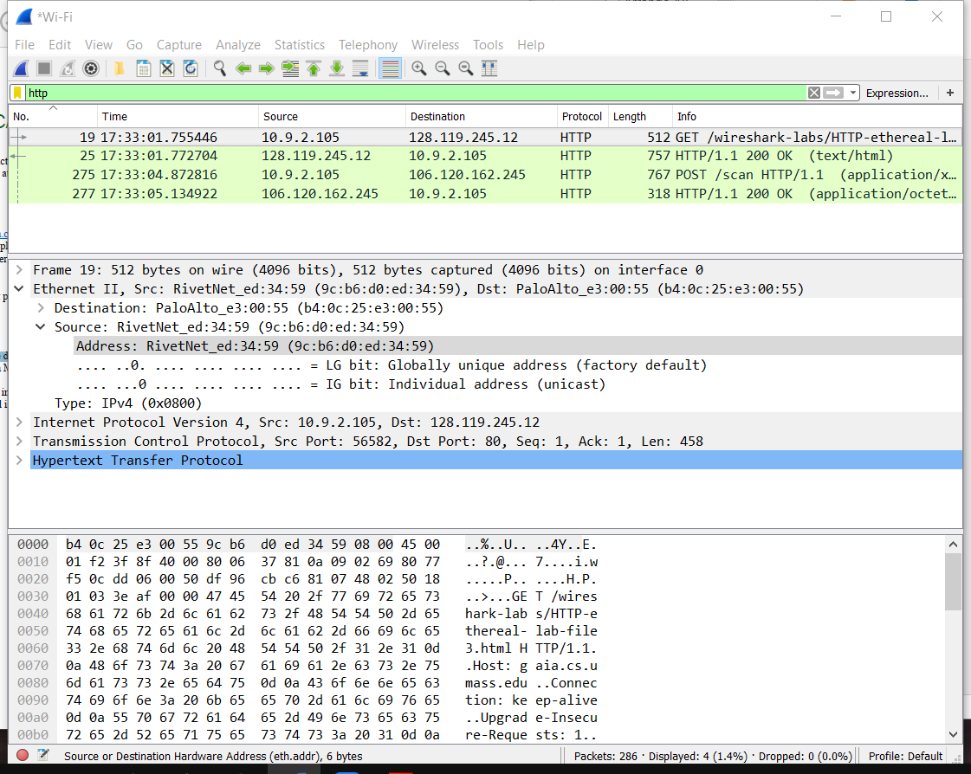**Answer**: My computer MAC address is 9c:b6:d0:ed:34:59

2. What is the destination MAC address?

**Answer**: The destination MAC address is b4:0c:25:e3:00:55

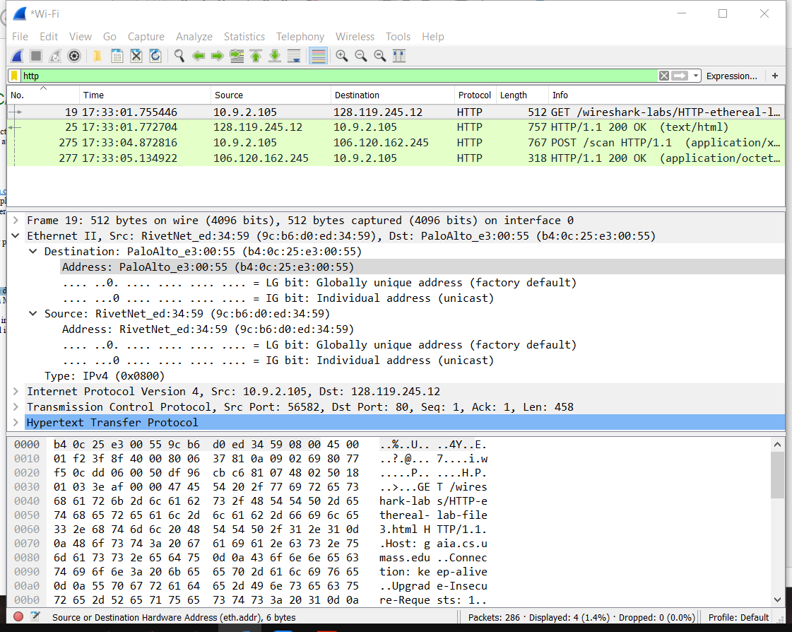

3. What **device** has the MAC address shown in the destination?

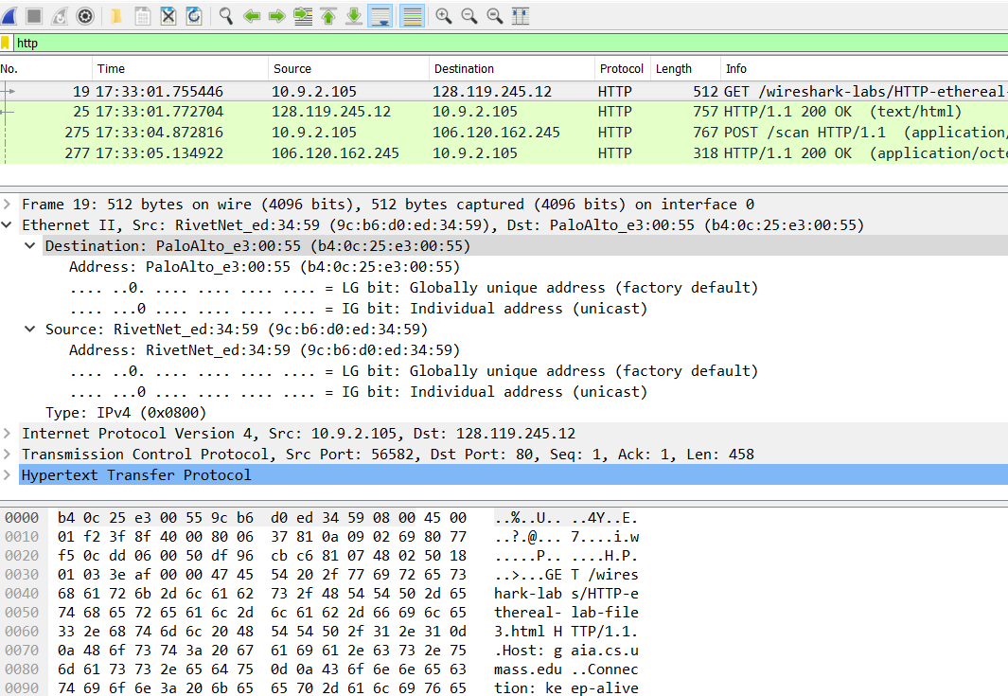**Answer**: The device with the destination MAC address is Palo Alto Networks (virtual router)

4. Explain the relationship between the destination **MAC** address and the destination **IP** address.

Answer:

a. The reason for configuring both MAC address and IP address:

* When a computer knows the destination IP address, the computer must also enter the router destination MAC address for the traffic. MAC addresses and IP addresses operate on different layers.
* IP addresses are used on layer 3 to identify machines throughout different **networks**. Because the IP Address is logical and routeable, all devices on the same network subnet are allowed to have same IP addresses which reduces the complication of the physical internet.
* MAC address is used to identify **machines** within the same broadcast network on layer 2.

It is given to a network adapter when it is manufactured. It is hardwired or hard-coded onto the computer's network interface card (NIC) and is unique.

In sum, MAC Addresses handle the physical connection from computer to computer, while IP Addresses handle the logical routeable connection from both computer to computer and network to network.

b. How to get MAC address from IP address:

The network uses protocol *ARP* to associate MAC addresses with IP addresses. ARP enables a computer to look up an unknown MAC address for a device that it wants to communicate with.

* To find out the MAC address, ARP lets devices on the network ask each other which MAC addresses they have. The computer creates an ***ARP request*** with a simple question like as “*Device with IP address x.x.x.x, reply back with your MAC address*”. ARP requests are sent as broadcasts and every other device on the LAN will receive the message. This is processed by the integrated switch in the Home Router which handles the message as a broadcast and forwards it to all other ports including the integrated router. The home router with the same IP address as in the request will read the message and will notice that the message is directed at itself. It will then construct an ***ARP reply***: *“I have IP address x.x.x.x and my MAC address is yy:yy:yy:yy:yy:yy”* and send it to the computer*.*

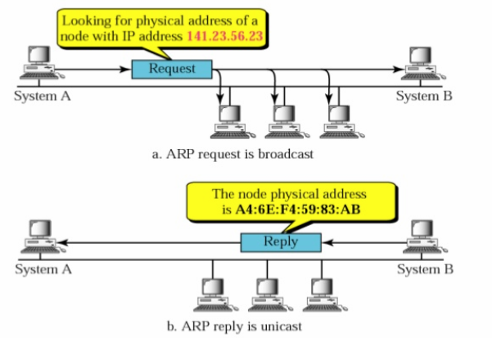

* Every time a computer receives an ARP reply it will save the response for at least a few minutes in an ARP table(or ARP cache) in memory. So, the computer doesn’t have to do an ARP request for each packet it wants to send.

Each time a computer is sending a packet to an IP address it will look in its ARP cache to see if it already knows what MAC address that is associated with that IP address.

5. Using the terminal (cmd in Windows, Terminal in mac), run a command to display your full ARP list table. (Find out what the command is, and print a full screen shot of your result.)

Answer: The command is arp -a

